Basic Pike Drill
V1.0, 5/25/02
Taken from Lloyd's Blewe ROF _Drillbook_ based on Thomas Callaway's "Manual of The Compleat Militiaman, Armes, Equipment & Drill of the St. Maries Citty Militia",
as modified by Bill Craig, Acting CO of Lloyds

ORDER YOUR PIKE –

Place the feet 9 inches apart with the right instep in line with the left toe. The pike is in line with the right toe, with the right hand at shoulder height. The left hand is on the left hip with fingers out.
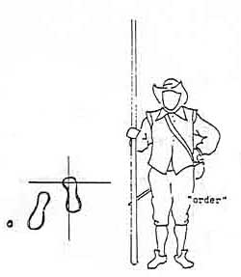

ADVANCE YOUR PIKE –

The pike is lifted vertically in three motions. The back of the right hand is in front of the pike, locking it firmly against the shoulder. The left hand is on the hip, with the fingers turned outward.
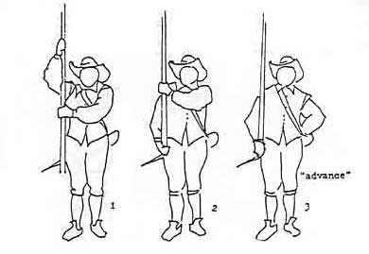
SHOULDER YOUR PIKE – (from Advance)

Grasp the pike with the left hand above the right. Lay the pike on the shoulder, releasing the right hand. Slide the pike forward to the extent of the left arm. Grasp the pike with the right hand, inclining it to 45 degrees with the butt approximately 18 inches from the ground. The right elbow is kept close to the side. Release the left hand, returning it to the left hip, palm out.
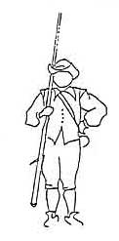
PORT YOUR PIKE – (from Advance)

Grasp the pike with the left hand over the right shoulder. Step back with the right foot and at the same time swing the pike forward, using the right arm as a pivot point, until the inside of the left forearm rests against the left side of the chest. Both hands and arms are in the same relative position to the pike as in the first step. The pike has been pitched forward to 45 degrees. The right hand is approximately 10 inches behind the right buttock.
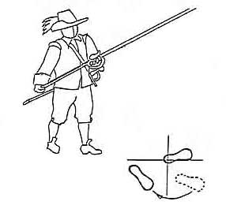
CHARGE YOUR PIKE – (from Port)

Bring the pike forward to the horizontal at shoulder level. Hands and arms nearly same relative position to pike as before. NOTE – While bringing pike forward, slide left hand approximately 12 inches up shaft so that when pike is horizontal, left hand is it’s own width forward of the left shoulder.

Keeping body upright, shift weight forward so that left knee is over left toe. NOTE – push of pike is from this position.

When the Company advances at “Charge your pike”, the first three ranks will be at the above position. All remaining ranks will stay at “Port”.

The entire Company will immediately switch to the Swedish step – left foot forward, right foot brought up behind the left foot. This is done to maintain position and balance, while at “Charge your pike”, and is to be maintained until orders given otherwise, such as “Halt!”

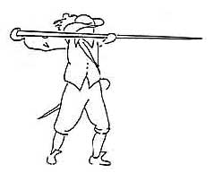
ORDER YOUR PIKES TO CLOSE ORDER – (from Order)

Grasp the pike with the left hand below the right. Keeping the pike vertical, lift it over the right foot so that the butt is approximately 12 inches from the ground. At the same time bow the head sharply so as to be looking down at the ground above the pike butt, aiming the pike butt to drive it sharply into the ground. Powerfully drive the pike butt into the earth to secure it between the feet, near the right instep. Then snapping the head back up sharply, just as the pike butt strikes the ground. Place the left hand on the hip, palm out.
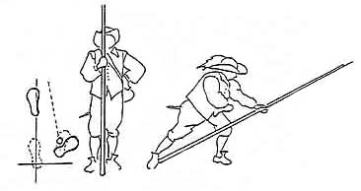
CHARGE FOR HORSE AND DRAW YOUR SWORD –
(from Order your pike to close order)

Step forward with the left foot, grasping the pike with the left hand just below the right. Bend forward until the left hand is at knee level and left forearm on the left knee. Hold butt of pike firmly against the right instep. Keep head up and eyes front.
Reach over the pike with right hand and draw the sword, holding it at arms length to the front.
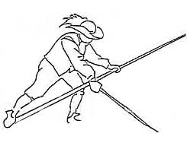
RECOVER YOUR PIKE AND PUT UP YOUR SWORD –

Stand erect, bringing the left foot back to the Order position. Holding the pike in the crook of the right arm, return the sword to the scabbard, which is held in the left hand. Return to Order.
LAY DOWN YOUR PIKE – (from Order)

On command, raise the pike with the right hand and grasp it with the left hand at waist level (as in the last movement of “advance your pike”).

Move the left foot forward a full pace. Release the pike with the right hand and grasp the butt of the pike (hand movement as in step 2 of “advance your pike”). Lower the point of the pike to the ground.

Return the left hand to the left hip. Bending the knee, lower the pike to the ground just to the right of the right foot. Stand and assume the “Order” position, with the right hand at the side, fingers slightly clenched.

HANDLE YOUR PIKE –

Moving the right foot a pace to the rear, bend the knee and grasp the pike with the right hand. Stand and return the right foot to “Order” position, with right hand holding the butt of the pike.

RECOVER YOUR PIKE –

Take one pace forward with left foot. Grasp the pike with the left hand. Lift the pike to the vertical, bringing the left foot back to the “Order” position (in effect the “Secure” position). The order may now be either to “advance your pike” (simply returning the left hand to the side) or “Order”.
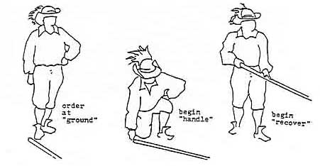
SECURE YOUR PIKE – (from Advance)

When passing in review or in high wind. On the command, grasp the pike at shoulder level with the left hand.
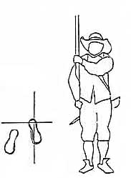

TRAIL YOUR PIKE – (from Advance)

When passing through woods or as rest from “advance” or “shoulder”.

On the command, grasp the pike with the left hand in front of the shoulder (Secure) and swing the butt of the pike to the rear.

Pass the pike backward hand over hand as you march, finally grasping the pike a few inches behind the head on the seventh count. Return the left hand to the left hip, fingers out.

To return to “Secure” or “Advance”, simply reverse the process.
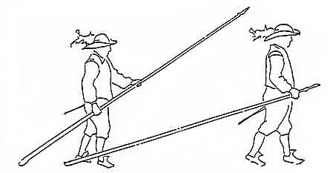
SALUTE – All Pikemen and Pike Officers (from Advance or Shoulder)

On the command, step back a full pace with the right foot, grasp the pike high with the left hand and go through the “Port” position. Bringing the right arm back and lowering the left arm, bring the pike within a few inches of the ground, pike to the front.
On “Recover”, the pike comes back through “Port” to original position – “Advance” or “Shoulder”.
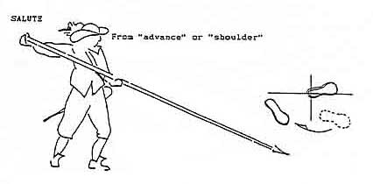

SALUTE – Officers only

This is the second phase of “Salute” for officers. Remove the hat with the left hand, sweeping it to the left at arm’s length.

When the reviewing officer has passed, on the drumbeat or the command “Recover”, place the hat on the head, and return the hand to the hip.
Helmeted – simply bow the head sharply at the “Salute”, then snap the head up sharply on the “Recover” command.

