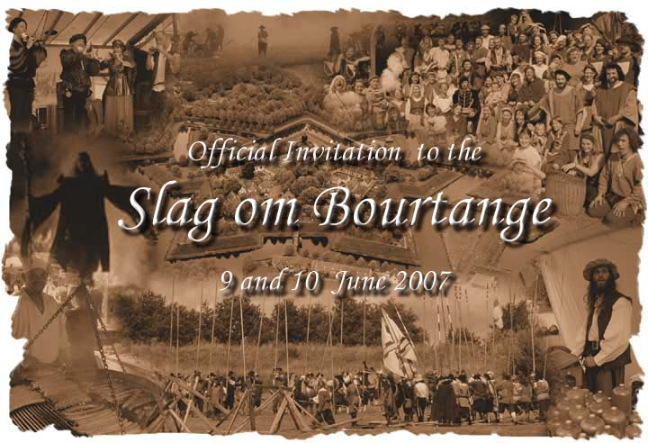

Culture and life during the 80 years persisting war

Travel back in time. Squads of soldiers out of past time march within the ramparts of Bourtange. The commanders are busy to assemble the soldiers to prepare for the nearby “battle for Bourtange”: The fortress will be beleaguered again. The Dutch army receives back up from constructive soldiers out of the rest of Europe.
Simultaneously the normal life sustains. Dozens of merchants are making attempts to sell their commodities. All kind of people populates the fortress. The barber, the smith, the maker of baskets, the weaver, but also the charlatans, jugglers and surgeons are present. This is the entirely authentic rustic life of the seventeenth century. The apparels, weapons and customs of nurture are accurate reproductions of advanced time. Experience the history from nearby!

Dear re-enactor

In Bourtange (NL) on the 9th and 10th of June this year one of the most beautiful events in time of the 80 Years War (1568 – 1648) will be taking place.
Not only impressive battles will be shown but also daily live can be seen in and around the fortress ramparts.

We would be very pleased if you and/or your group want to participate at this event.
Registration and information on the website of the fortress: www.bourtange.nl

We hope to welcome you in the weekend of the 9th and 10th of June in Bourtange.

On behalf of the organisingcommittee Fortress Bourtange,

Jaap Speelman

